**Lesson 3 Demo 1**

**Sprint Planning in Jira**



Steps to be followed:

1. Create a backlog
2. Create new issues
3. Edit the sprint

**Step 1: Create a backlog**

* 1. We have already created a project called eStore.

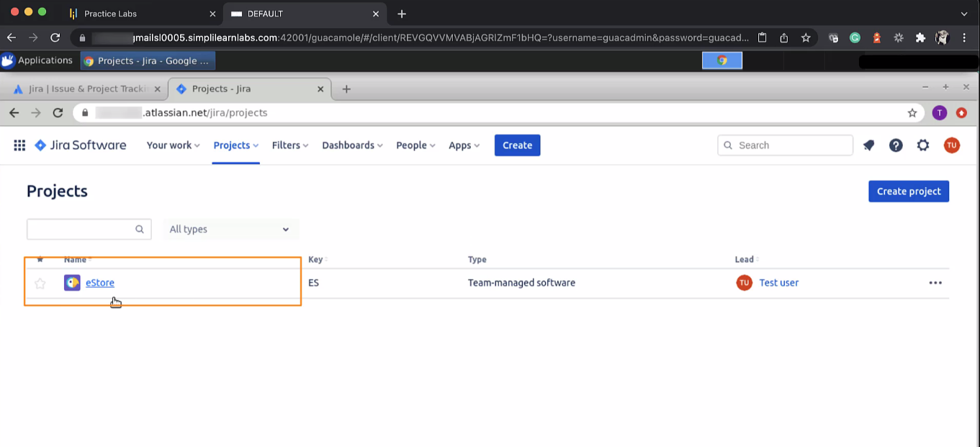

* 1. Go to backlogs. A story was already created, which is available in the backlog.

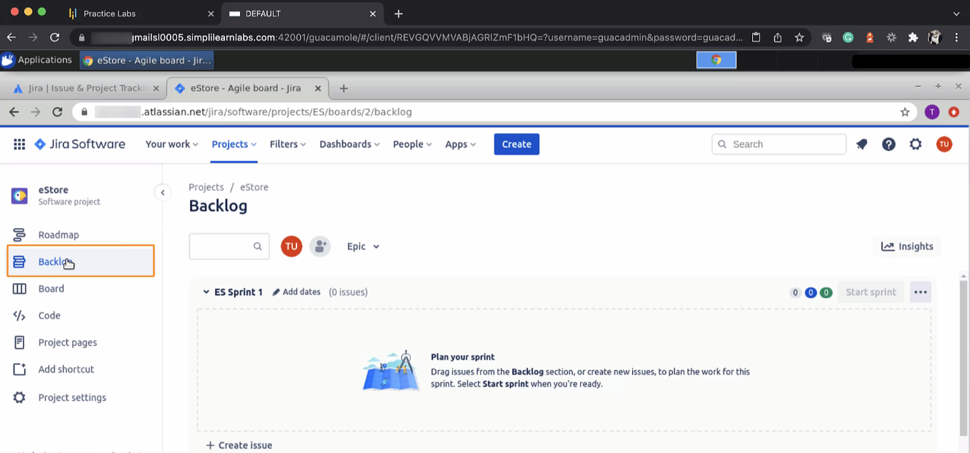

* 1. The backlog story was the authentication story.

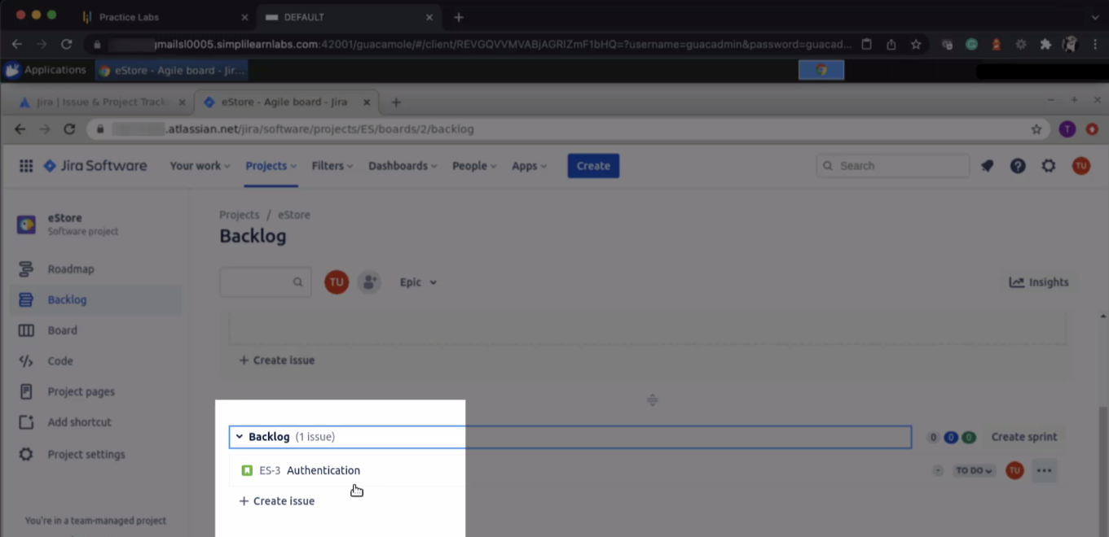

* 1. Click on the authentication story, and it will give you the description of the story.

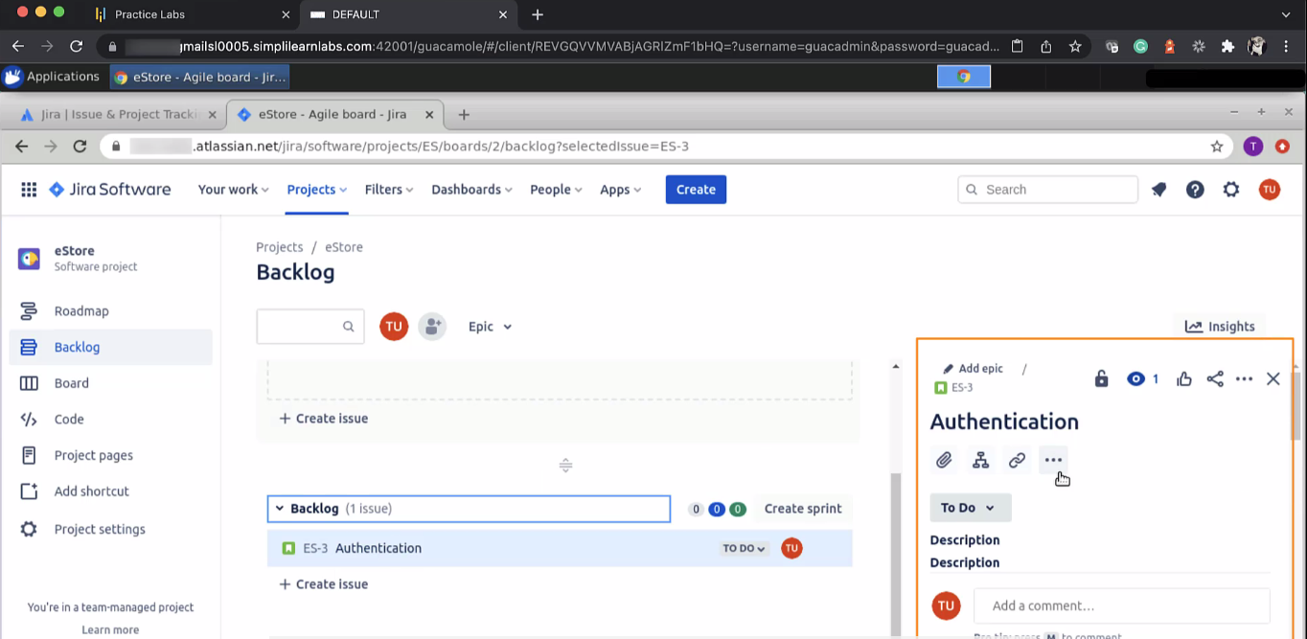

* 1. All backlog stories will be listed under the backlog section.

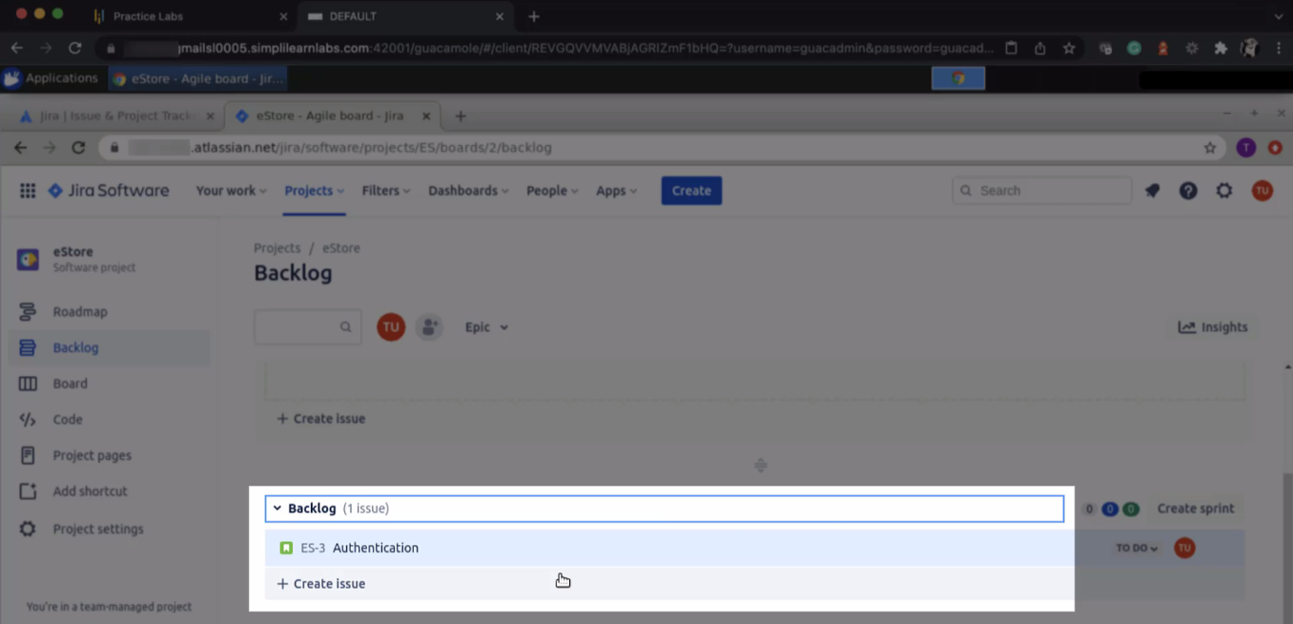

**Step 2: Create new issues**

* 1. You can create more issues as well. Click on the **create issue** button and give it a name. It will be one more story. You can also add a description to it.

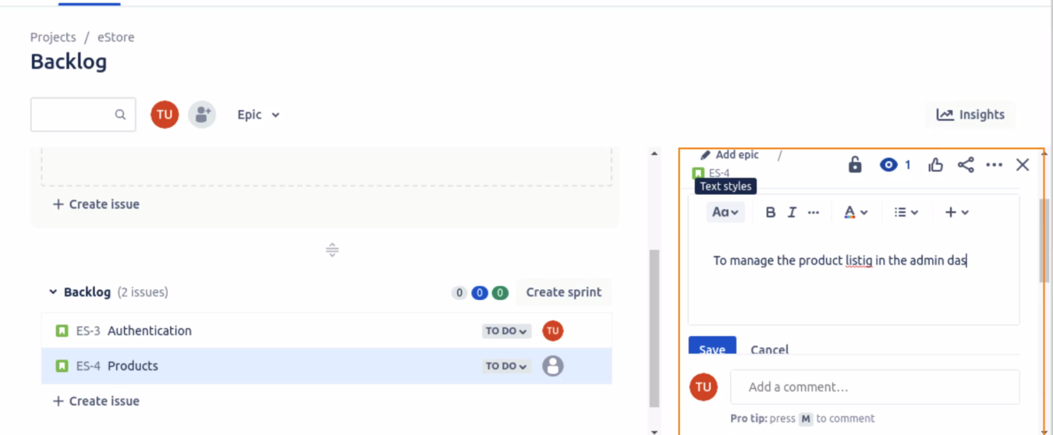

* 1. Click on **save**
  2. Create more issues under the task. Change the issue type to the task

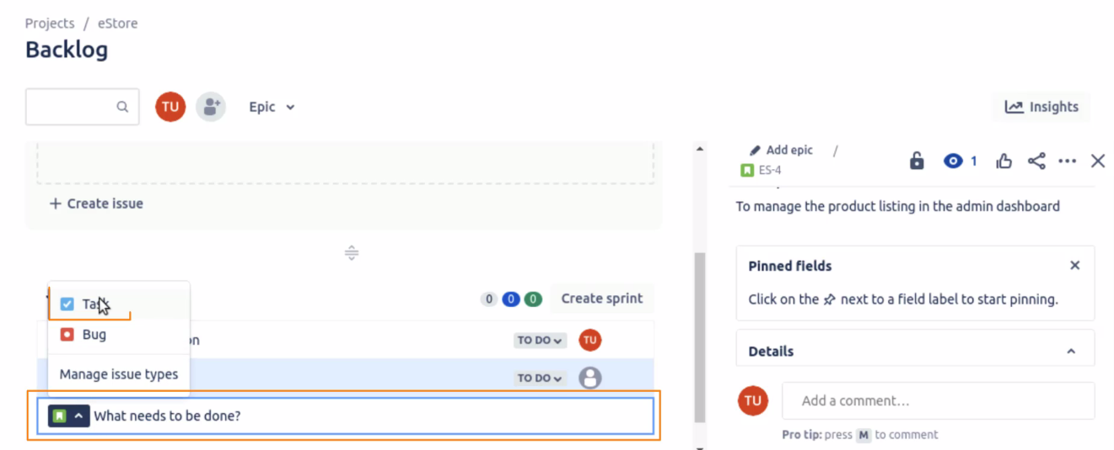

* 1. Create multiple tasks for the web page creation. We have created the below four tasks.

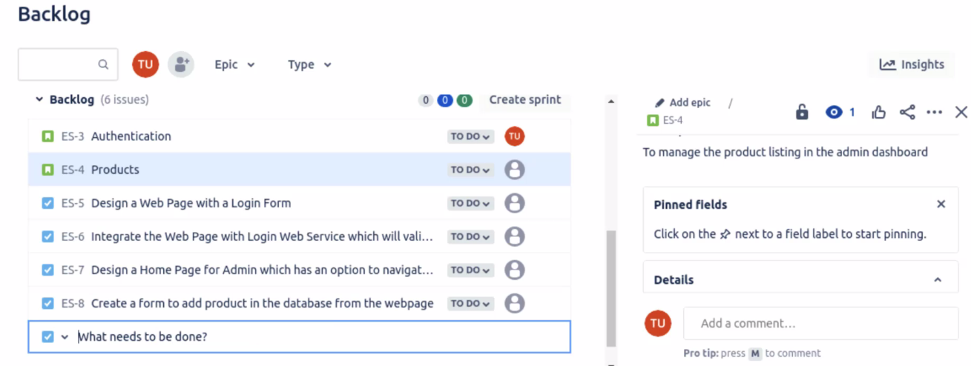

* 1. When you click on the task, all the editing can be done on it, like linking it to a relation, adding descriptions, and so on

**Step 3: Edit the sprint**

* 1. You can see a section for sprint planning when you scroll up.

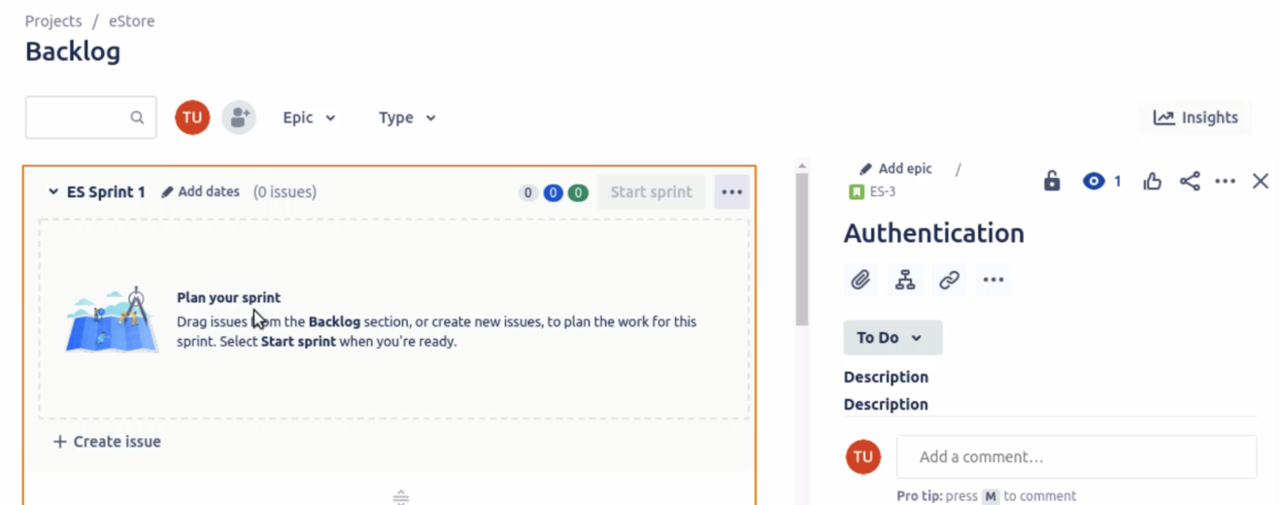

* 1. To plan the sprint, drag and drop the issues from the backlog and put them under sprint, which will then become a part of the sprint planning

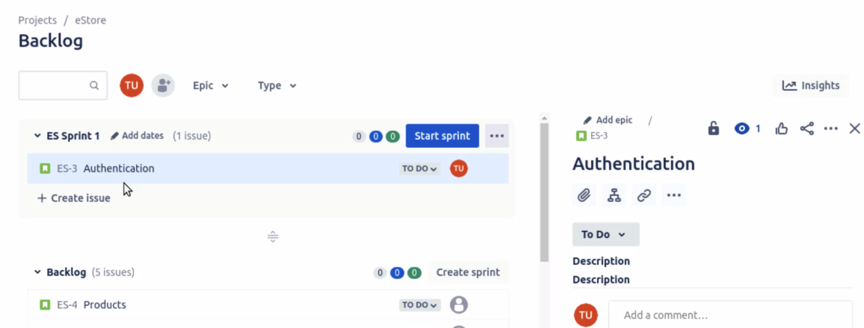

* 1. Similarly, drag and drop the task you or the team would be working on in the current sprint

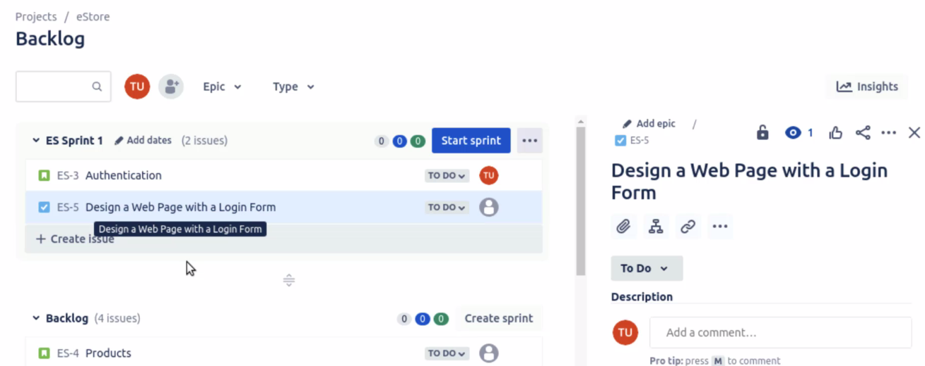

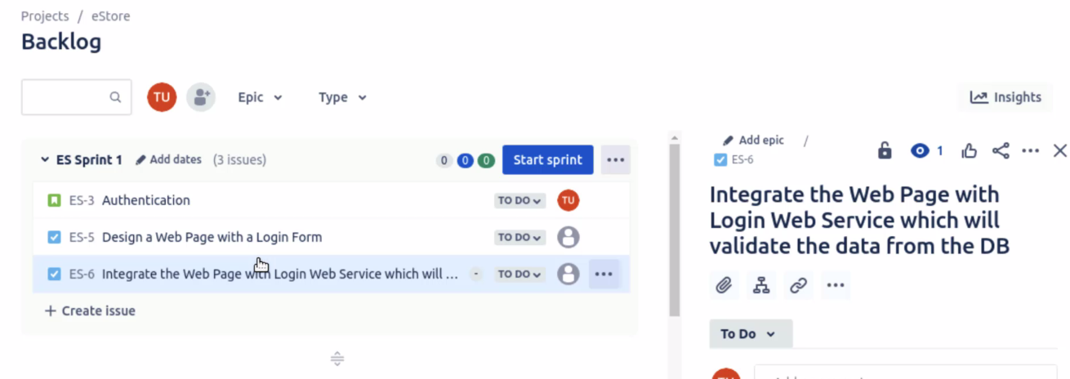

* 1. You can notice that every issue has a story point. Click on one of them, say, the Authentication story and add points to it. These points can be decided using the poker planning game as well.

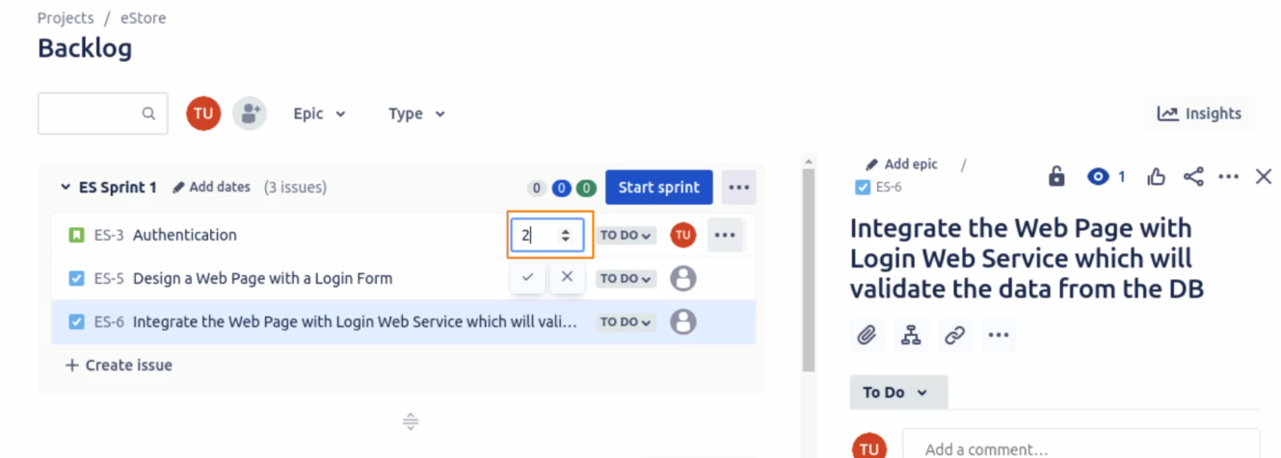

* 1. Click on the three dots and click on Edit sprint

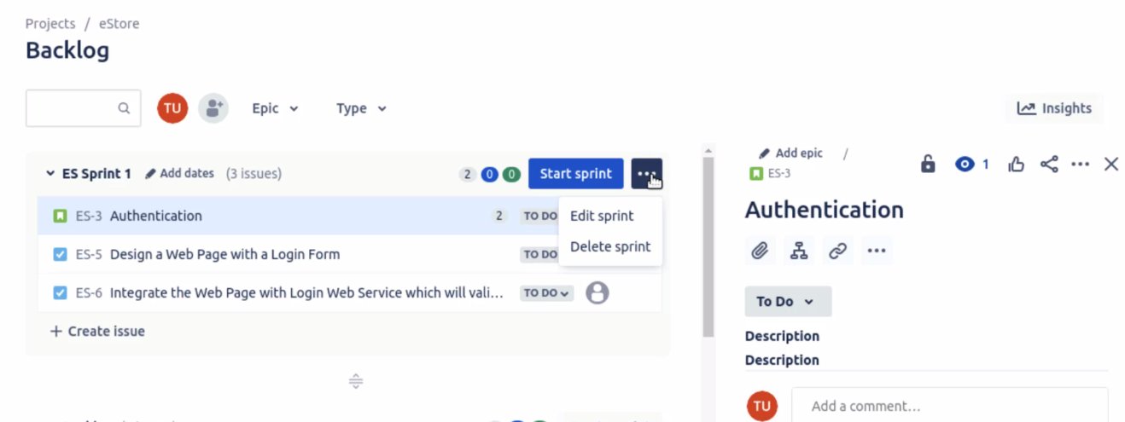

* 1. Edit the Sprint name and the other details, like the Sprint goal

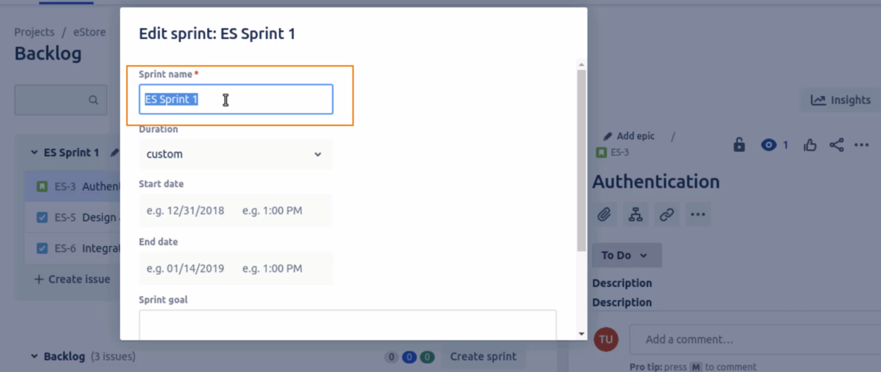

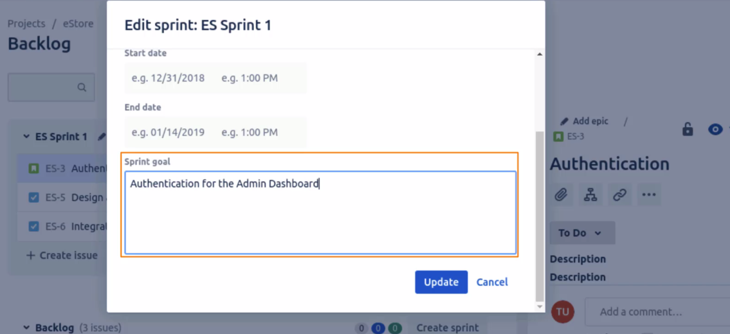

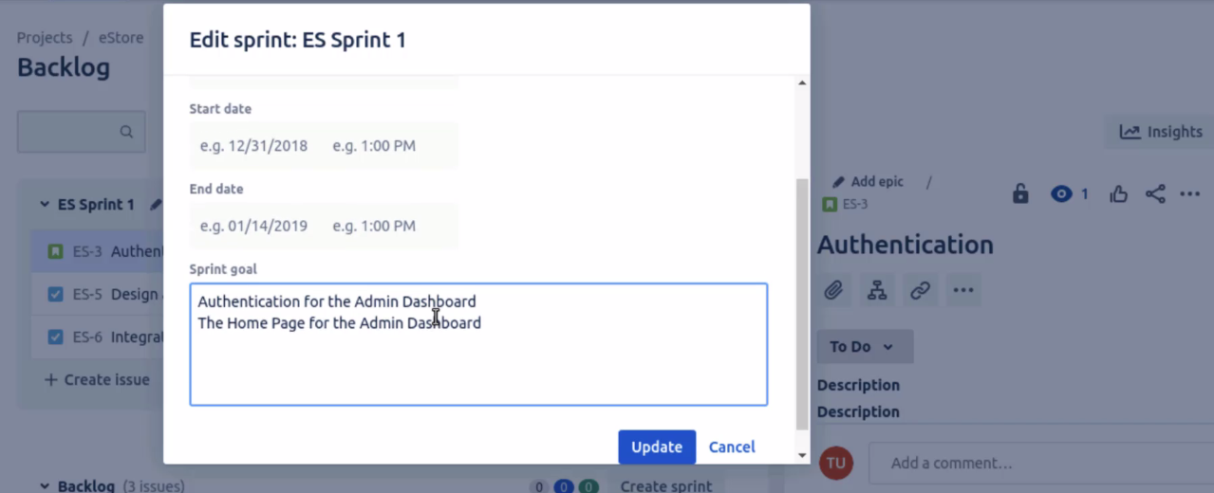

* 1. Add the duration, Start date, and End date for the sprint

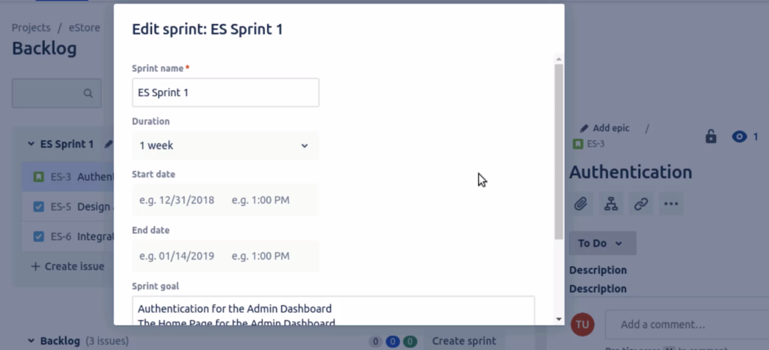

* 1. Once done, click on the **update** button
  2. Lastly, once everything is done, click on the **Start sprint** button to start the sprint

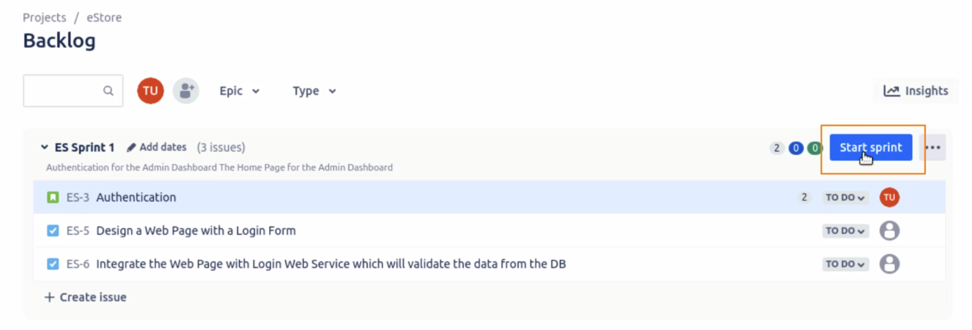

* 1. Before that, you can also assign the team members who will be working on the tasks. Click on the icon and assign it to the member.

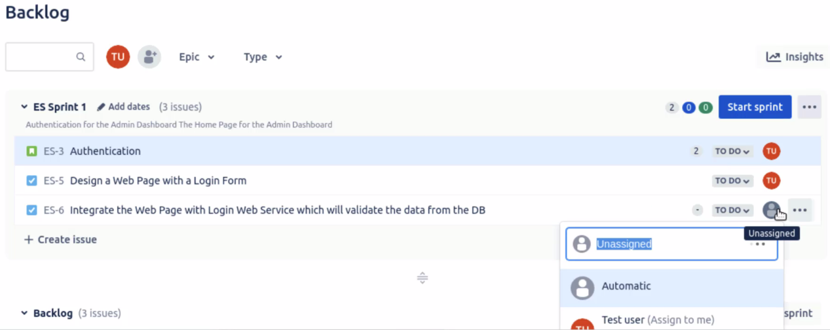

* 1. More people can be added by clicking on the + icon

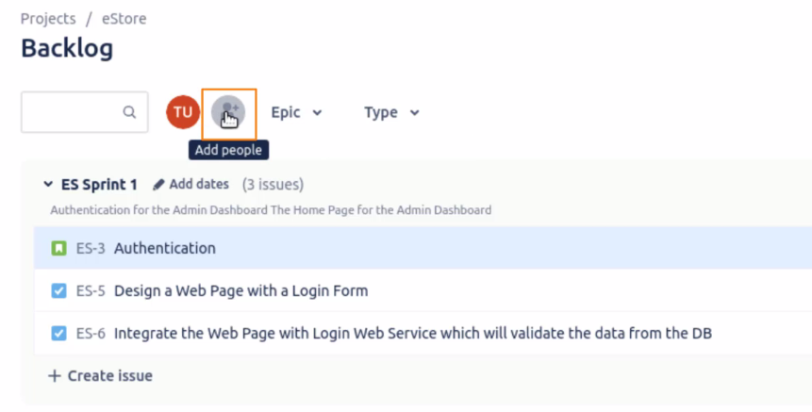

* 1. Click on the **start sprint** button. Specify the details and click on the start button.

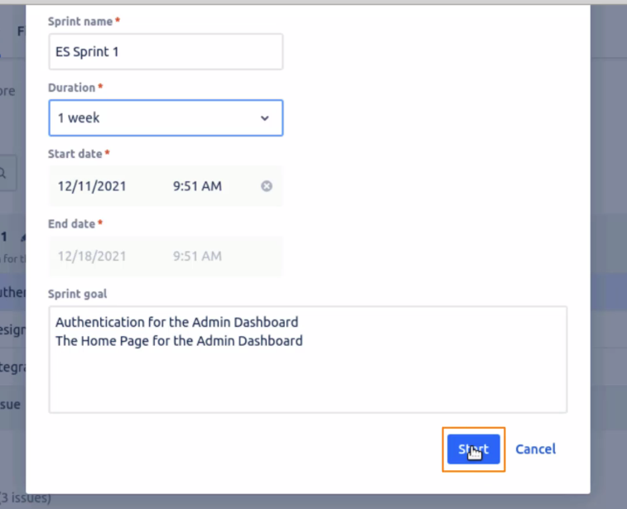

* 1. You will be navigated to the dashboard, where you can see the tasks under the **TO DO** tab.

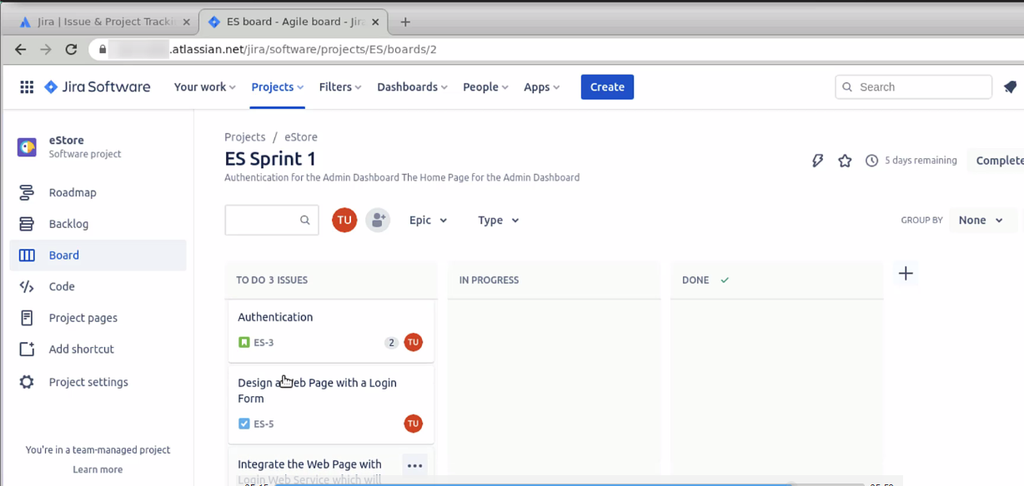

* 1. The status of the issue can be changed. Click on the task and change the status to **In progress**.

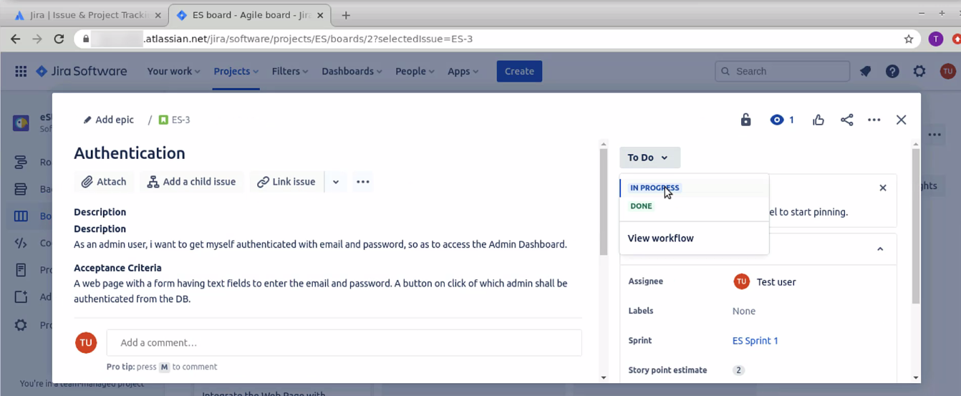

* 1. You can see the story has moved to an in-progress state.

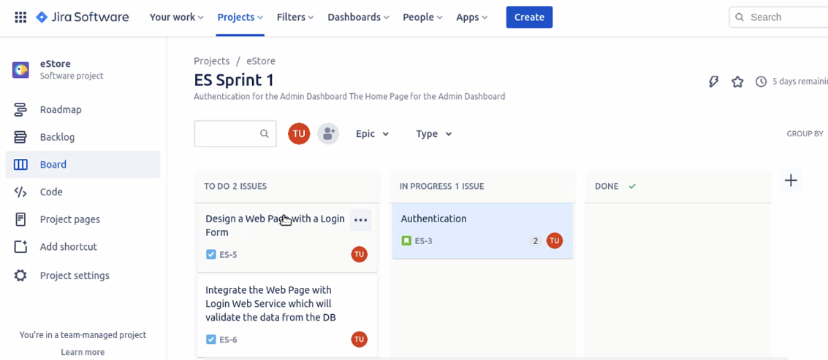

* 1. Once the task is completed, move the status to the **Done** state, and it will be moved to the Done state.

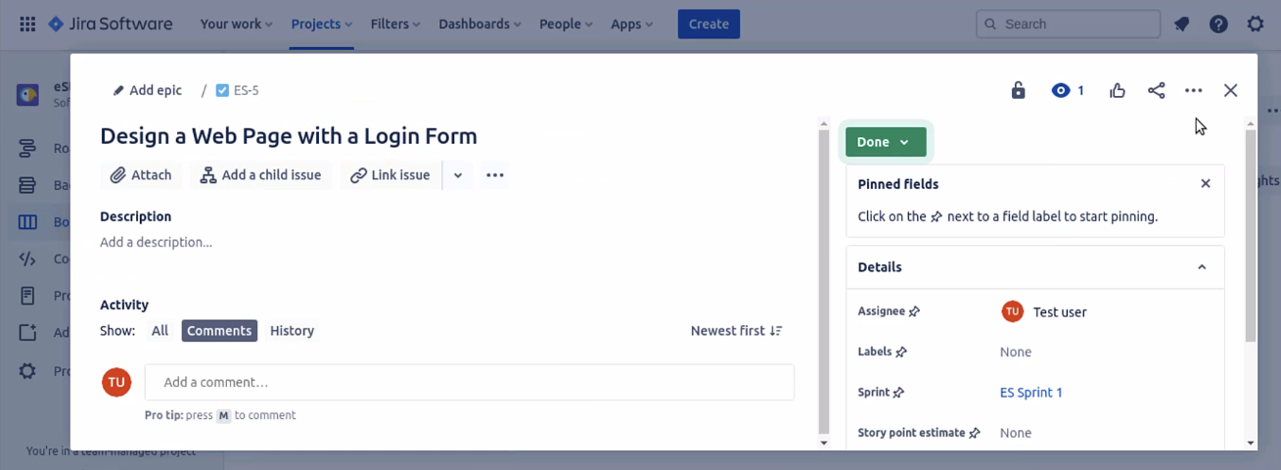

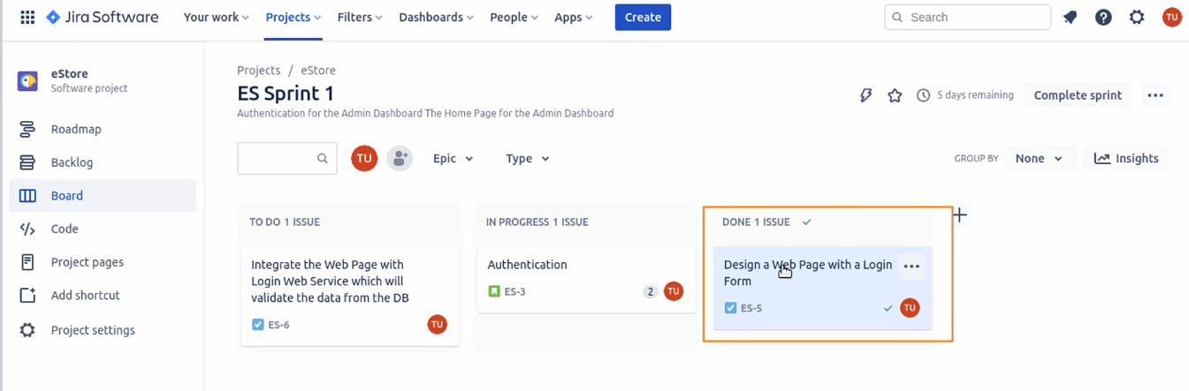

So, this is how you can do the sprint planning in Jira.